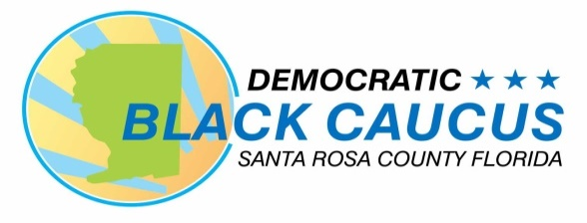

SANTA ROSA DEMOCRATIC BLACK CAUCUS
IS ONE OF OVER 50 COUNTY CHAPTERS OF
THE FLORIDA DEMOCRATIC BLACK CAUCUS!

YOUR MEMBERSHIP IN THE SANTA ROSA
COUNTY DEMOCRATIC BLACK CAUCUS ALSO MAKE YOU A MEMBER OF THE STATEWIDE CAUCUS WITH FULL VOTING RIGHTS IN BOTH!

LYDIA HUDSON, PRESIDENT

MEMBERSHIP APPLICATION
JOIN US!

MEETING THE CHALLENGES OF
TOMORROW THROUGH A
STRONGER DEMOCRATIC
VOICE!

Your membership will enable us to carry out our mission and meet our objectives for the citizens of Santa Rosa County and the Florida Democratic Party. With your help we will be able to impact the ballot and public policy to build a Florida that respects the rights of all Black citizens!

Christina Forrest, President
Santa Rosa Democratic Black Caucus
P. O. Box 4700
Milton, Fl 32572
850-912-9091
santarosadbc@gmail.com
www.srcdbc.org

MISSION
The Santa Rosa County Democratic Black Caucus
(SRCDBC) was established to build up and
reinforce the Florida Democratic Party and to unite
and increase the political power for Black Democrats
by engaging, educating, and empowering the citizens
of Santa Rosa County. SRCDBC works to elect
members to become leaders in the Florida Democratic
Party and work diametrically with local and state
Democratic leaders and elected officials, the Democratic
Black Caucus of Florida, Democratic Executive
Committees, and the Florida Democratic Party.

VISION
As a result of its work and its standing in solidarity in
addressing issues that are impacting our daily lives,
SRCDBC can develop solutions and strategies to
address these issues. As we lift and educate
the voters of Santa Rosa County, we will in turn impact
the Ballot and public policy to build a Florida that
respects the rights of all Black citizens, and provides
access to quality healthcare and jobs, addresses
pervasive poverty, supports public employees, and
insures that all citizens can fully exercise their voting
rights and civil liberties.

JOIN SRCDBC!

Fill out the form below and submit with the annual membership fee as appropriate:

_______ x $50 for ages 64 and younger: Total $___________

_______ x $30 for seniors (65+) /students: Total $___________

Note: $35 of adult and $15 of senior/student membership fee goes to the Democratic Black Caucus of Florida, which makes you a member of both the state and local DBC.

Date:_________________________

Name:_____________________________________________________

Name:_____________________________________________________

Address:___________________________________________________

City:_________________________ Zip:__________________

County:_________________________ Congressional District:_________

FL House District: ______________ Senate District:_________________

E-mail:_____________________________________________________

Phone Number:______________________________________________

Occupation: _________________________________________________

Political/Committee/Service Interests:_____________________________

_________________________________________________

New Member:________ Renewal Membership ___________

Signature:_________________________________________

Make checks or money orders payable to:
Santa Rosa County Democratic Black Caucus or SRCDBC
Mail to: P. O. Box 4700, Milton, Fl 32572

